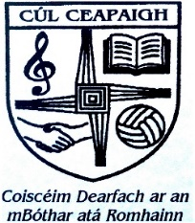
Coolcappa N.S.
ANNUAL ADMISSIONS NOTICE
in respect of admissions to the 2024/2025 School Year

Admission Policy and Application Form
A copy of the school’s Admission Policy and the Application Form for Admission for the 2024/2025 school year is available online at www.coolcappans.com

PART 1 - Admissions to the 2024/2025 school year
Application and Decision Dates for admission to Coolcappa NS 2024/2025
The following are the dates applicable for admission to Junior Infants

The school will commence accepting applications for admission on | January 8th 2024
The school shall cease accepting applications for admission on | April 8th 2024 at 3pm
The date by which applicants will be notified of the decision on their application is | April 15th 2024
The period within which applicants must confirm acceptance of an offer of admission is | April 22nd 2024
Note: the school will consider and issue decisions on late applications in accordance with the school’s admission policy.
Failure to accept an offer within the prescribed period above may result in the offer being withdrawn
Number of places being made available in 2024/2025
The number of places being made available in Junior Infants in 2024/2025 is 12

